

Patient Safety Incident Response Policy v1.0
Document Type | Policy
Document Number
Document Owner / Author: | Chief Nurse and AHP Officer
Document Service / Designation | Trust wide
Approval / Ratification | Quality Committee
Medicines | Chief Pharmacist
Standards, legislation or key related documents (including related Policies & SOPs) | It is the responsibility of the relevant staff groups to act in accordance with this document. During the process of becoming a single trust from the 1st April 2026, there is an agreed process for harmonising documents, and predecessor documents will still be applied - for further advice contact the Head of Corporate Governance.  Key related documents include:  - https://www.england.nhs.uk/patient-safety/patient-safety-insight/incident-response-framework/  - Complaints Concerns and Compliments (Patient Experience)  - Supporting Staff Involved in an Incident or Complaint  - Being Open and Duty of Candour  - Patient Safety Incident Response Framework Policy  - Incident Review Process SOP  - Freedom to Speak Up Policy  - Reward and Recognition for Involvement Partners  - NCH&C Risk Management Strategy  - NCH&C Risk Management Policy  - NCH&C Information Governance Policy  - NCH&C Duty of Candour (Being Open) Policy  - NCH&C Claims Policy  - NCH&C Complaints Policy  - NHS England Never Events list 2018  - Any other relevant documents
CQC Domain | Safe, Effective, Responsive, Caring, Well-led
Keywords | PSIRF, patient safety, patient safety incident response policy, patient safety incidents, incidents

This is a controlled document. Whilst it may be printed, the electronic version on the Trust’s Intranet is the controlled copy. Any printed copies are not controlled.

Version Control Summary

Version Number | Name and Title of Author or Committee | Description of Change to Document or Status (including page or section) | Date Approved
1.0 | N/A | Combined PSIRF policy created for the new Trust

Patient Safety Incident Response Policy v1.0

Contents

Section |  |  | Page
 | Version Control Summary
1 | Introduction / Purpose |  | 6
2 | Scope |  | 6
3 | Duties, Roles and Responsibilities |  | 6
4 | Training / Competency |  | 8
5 | Our Patient Safety Culture |  | 9
6 | Duty of Candour |  | 10
7 | Addressing Health Inequalities |  | 10
8 | Engaging and Involving Patients, Families and Staff following a Patient Safety Incident |  | 10
9 | Our Patient Safety Incident Response Plan |  | 10
10 | Responding to Patient Safety Incidents |  | 11
11 | Timeframes for Learning Responses |  | 13
12 | Being Fair Tool : Supporting Staff following a Patient Safety Incident |  | 13
13 | Safety Action Development and Monitoring Improvement |  | 13
14 | Safety Improvement Plans |  | 14
15 | Complaints and Appeals |  | 14
16 | Managing Communications with the Media and other External Agencies |  | 14
17 | Structure for Local Incident Reviews and Governance |  | 15
18 | Monitoring and Audit for Compliance |  | 17
19 | Equality Impact Assessment (EIA) and Quality Impact Assessments (QIA) |  | 17
Appendices
Appendix 1 |  | Patient Safety Specialist job requirements | 19
Appendix 2 |  | Guidance for the support process | 20
Appendix 3 |  | Guidance for the process of involvement, engagement and support | 21
Appendix 4 |  | Guidance for reviewers talking to Service users | 22
Appendix 5 |  | Guidance for reviewers talking to Staff | 23

- Introduction / Purpose

  - The Patient Safety Incident Response Framework (PSIRF) promotes a coordinated, data-driven, system-based approach to responding to patient safety incidents for the purpose of learning and improvement. This policy sets out how we will respond proportionately to incidents, engage compassionately with all those affected (staff, services users and their families / carers), and focus oversight on strengthening responses and improvement.

It integrates the four key aims of PSIRF, supporting a just and learning culture:
- compassionate engagement and involvement of those affected by patient safety incidents (PSIs),
- application of a range of system-based approaches to learning from PSIs,
- considered and proportionate responses to PSIs and safety issues,
- supportive oversight focused on strengthening responses and improvement.

- Scope

  - This policy is specific to patient safety incident responses conducted solely for the purpose of learning and improvement across the services that we provide.

Response types that are outside the scope of this plan include those resulting from the below where there is no patient safety concern or risk:
- Complaints
- Human resources investigations
- Professional standards investigations
- Coronial inquests
- Criminal investigations
- Claims management
- Financial investigations and audits
- Safeguarding concerns
- Information governance concerns
- Estates and facilities issues

- Duties, Roles and Responsibilities

  - Chief Executive Trust Board - Our principal accountability is to patients / service users and their families / carers. In the fulfilment of our duty in this regard, the Board has ensured that an appropriate incident management system is in place for the reporting and monitoring of incidents, for effective governance and learning through assurance of our patient safety incident response plan. The Board also takes responsibility for leading and role modelling the development of a just, open and learning culture.

The Chief Executive is accountable and responsible to the Board for ensuring that resources, policies, and procedures are in place to ensure the effective reporting, recording, review and treatment of incidents. They have overall responsibility for ensuring there are processes that support an appropriate response to patient safety incidents, the development of a patient safety reporting, learning and improvement system and that systems and processes are adequately resourced.
  - Chief Nurse and AHP Officer and Chief Medical Officer
- Are our nominated leads responsible for ensuring we have appropriate arrangements in place for the management of incident / patient safety event reporting and associated reviews or learning responses.
- Lead in the formation and implementation of the clinical strategy, taking a lead on clinical standards in relation to the quality and safety of care, and providing clinical advice to the Board.
- The responsibility for defining and verifying an adverse event as a Patient Safety Incident Investigation (PSII) rests with either our Chief Nurse and AHP Officer or Chief Medical Officer (or a nominated delegate in their absence) as part of the patient safety incident response plan. Once verified, they will ensure the appropriate internal and external reporting is carried out and the review or learning response commences in accordance with this policy.

  - Service Director and Executive Team - All Service Directors are responsible for ensuring incident reporting arrangements, as described in this and related policies / procedures, are implemented throughout their service areas, for the implementation of Duty of Candour, improvement actions and the dissemination of learning following patient safety incidents.

  - Deputy Chief Nurse and Patient Safety Specialists
- The role of the Patient Safety Specialist (PSS) will be jointly undertaken across the Trust by individuals who together will meet the requirements of the role as outlined in the national job description (see Appendix 1).
- The Deputy Chief Nurse and PSS’ will be responsible (on behalf of the Chief Nurse and AHP Officer and the Chief Medical Officer) for overseeing the development and review of the patient safety incident response plan, ensuring that PSIIs are undertaken for all incidents that require it (as directed by our patient safety incident response plan) and that there are sufficient resources to support delivery (including support for those affected where required).
- They are also responsible for ensuring that there are processes that support an appropriate response to patient safety incidents (including contribution to cross-system / multi-agency reviews and / or investigation where required), that the executive and non-executive team can access relevant safety incidents including the impact of changes following incidents, and that processes for preparing for and responding to patient safety incidents are reviewed as part of overarching governance arrangements.
- The Deputy Chief Nurse and PSS’ will meet these duties through delegated responsibility to the Quality team.

  - Clinical, Operational, Service and Senior Leads will:
- Ensure that incidents are reported and managed in line with internal and external requirements.
- Ensure that they and their staff are familiar with PSIRF, the patient safety incident response plan and this policy, and support the development and delivery of improvement actions in response to patient safety reviews / PSIIs that relate to their area of responsibility.
- Provide protected time for participation in learning responses / PSIIs as required.
- Work with teams to ensure those affected by patient safety incidents have access to the support they need.

  - Learning response leads / Reviewers - Learning responses will be led by learning response leads who have experience and training in conducting patient safety incident responses and in the involvement and engagement of those affected, or be supported by an individual who has.

  - Patient Safety Partners - The NHS Patient Safety Strategy promotes the involvement of patients / service users, families, and carers as partners both in their own care and in the wider oversight of healthcare. Our Patient Safety Partners are supported by a named individual in the Trust, access regular supervision and have been involved in the development of our patient safety incident response policy and plan. They support the voices of services users to be heard at all levels of the organisation through:
- membership of safety and quality committees whose responsibilities include the review and analysis of safety data,
- involvement in patient safety improvement projects,
- working with teams and services to consider how to improve safety,
- involvement in relevant staff patient safety training,
- participation in investigation oversight groups where appropriate,
- participation in projects that focus on learning and involvement
- where appropriate, Patient Safety Partners may work across the Integrated Care System and participate in local system Patient Safety Partner networks / Communities of Practice as required and relevant.

  - All staff will:
- Understand their responsibilities in relation to the patient safety incident response plan, policy and PSIRF and act accordingly.
- Report all incidents and near misses within 24 hours or next working day of the incident occurring, using the DATIX incident reporting system whether substantive, bank, agency, student, interim contractors or other temporary staff.

- Training / Competency
  - Learning Response Training
Learning response leads will have completed level 1 (essentials of patient safety), and level 2 (access to practice) of the patient safety syllabus in addition to undertaking continuous professional development in incident response skills and knowledge, and at least two days’ formal training and skills development in learning from patient safety incidents / safety events or be supported by an individual who has. They will contribute to a minimum of two learning responses per year.

All our staff leading learning responses will be able to:
- Apply human factors and systems thinking principles to gather qualitative and quantitative information from a wide range of sources.
- Summarise and present complex information in a clear and logical manner and in report form.
- Manage conflicting information from different internal and external sources.
Communicate highly complex matters and in difficult situations.

  - Engagement and Involvement Training
Engagement and involvement with those affected by patient safety incidents will be led by learning response leads who will have had at least six hours of training in involvement and engagement, or be supported by an individual who has.

In addition, competencies and behaviours include:
- Communicating and engaging with patients / service users, families, staff, and external agencies in a positive and compassionate way.
- Listening and hearing the distress of others in a measured and supportive way.
- Maintaining clear records of information gathered and contact with those affected.
- Identifying key risks and issues that may affect the involvement of patients / service users, families, and staff.
Recognising when those affected by patient safety incidents require onward signposting or referral to support services.

  - Oversight training
All patient safety incident response oversight is led / conducted by those with at least two days formal training and skills development in learning from patient safety incidents, and one day training in oversight of these.

- Our Patient Safety Culture
  - This section should be read alongside the Supporting Staff Involved in an Incident or Complaint SOP.

PSIRF strives to be a framework that supports the development and implementation of an effective patient safety incident response system that supports system-based learning and takes a proportionate approach. The following principles underpin our oversight of patient safety incident responses:
- Improvement is the focus
- Blame restricts insight
- Learning from patient safety incidents is a proactive step towards improvement
- Collaboration is key
- Psychological safety allows learning to occur
- Curiosity is powerful

Using these principles, we will continue to foster open and transparent reporting reflective of a just and learning culture. Service users, carers, families and staff are encouraged to share feedback, raise concerns, compliment, highlight good practice and if needed, supported to make a complaint through well-established channels such as:
- Friends and Family Test surveys
- Access to the Patient Advice and Liaison Service
- Freedom to Speak up Champions and the Trust Freedom to Speak up Guardian
- Access to and advice from the Human Resources and Workforce team
- Support from union representatives

- Duty of Candour
  - Keeping our service users safe is a responsibility we all hold and so we strive every day to ensure that we cause no harm. All Trust employees work hard to provide services which are safe and of a high quality; however, it is a fact that despite this, sometimes things can and do go wrong and incidents will occur.

When this happens, we will respond quickly and positively to ensure the wellbeing of the people who use our services and our employees. The Being Open and Duty of Candour policy provides guidance for staff on the processes and steps to follow in supporting patients and carers following an incident meeting the requirements for the provision of Duty of Candour. It sets out specific requirements to follow when things go wrong with care and treatment, including informing people about the incident, providing reasonable support, providing truthful information and an apology.

- Addressing Health Inequalities
  - PSIRF allows a more flexible approach and intelligent use of data to identify disproportionate risk to specific groups, consider inequalities when developing safety actions, and tailor engagement to varied needs. We will collect and analyse demographic data where appropriate to reduce inequality gaps, as well as use these to identify emerging risks, trends or themes.

- Engaging and Involving Patients, Families and Staff following a Patient Safety Incident.
  - Learning and improvement depend on supportive systems and processes. We will work with those affected, ensure we are open and transparent, uphold

Duty of Candour, answer questions, signpost support, and co-agree terms of reference when appropriate.

Guidance on making initial, ongoing and closing contacts is provided in Appendix 4.

- Our Patient Safety Incident Response Plan
  - As of the 1st April 2026, Norfolk Community Health and Care and Cambridgeshire Community Services Trust joined to become East of England Community Health and Care Trust.

A key part of the success of both Trusts has been our approach to embracing the principles and approaches of PSIRF. A new Patient Safety Incident Response Plan has been developed from the individual risk profiles of the predecessor Trusts using the organisational data which has been reviewed and triangulated to provide insight.

Our new Patient Safety Incident Response plan sets out how we intend to respond to patient safety incidents over a period of 12 months, commencing April 1st 2026, and has been derived from a 3 year look back of data from various sources including incidents, complaints, and staff feedback.

The plan is not a permanent set of rules and we will remain flexible and consider the specific circumstances in which each patient safety incident occurred and the needs of those affected. It forms is a ‘living document’ that will be appropriately amended and updated as we use it to respond to patient safety incidents and to reflect any emerging themes, trends or risks.
Updated plans will be published on our website, replacing any previous version.

A rigorous planning exercise will be undertaken every three years (and more frequently if appropriate, as agreed with our Integrated Care Boards) to ensure efforts continue to be balanced between learning and improvement.

- Responding to Patient Safety Incidents
  - Patient safety incident reporting arrangements
All PSIs must be reported via DATIX and where needed, through LFPSE (Learn From Patient Safety Events) and to notifiable partner organisations using the approved processes. We will continue to work with all statutory bodies, such as the police, and ensure that all statutory reporting is completed, e.g., to the Health and Safety Executive (HSE) and the Medicines and Healthcare Products Regulatory Agency (MHRA) where needed. The processes contained within this document do not supersede the normal legal requirements to notify other agencies when required.

We will also continue to work with organisations and co-operate with any learning responses that cross organisational boundaries.

As part of incident reporting, all staff are required to:
- Report all incidents, patient safety events and near misses via the electronic incident management system, Datix.
- Ensure the details of any incidents / patient safety events are contemporaneously and objectively reported in the patient / service user’s clinical record as appropriate.
- Raise any concerns about situations that led to, or could lead to, an incident, patient safety events or a near miss with their line manager or the Quality Team.
- Actively participate in any subsequent reviews or learning responses, providing an account, attending multidisciplinary fact-finding and feedback meetings etc as needed.
- Attend a Coroner’s inquest if called to do so.
- Undertake mandatory training in the reporting of incidents / patient safety events.
- Undertake additional training, as required, to ensure competence in relation to the Datix system.

Further details of incident reporting arrangements are detailed in the Incident Review Process SOP.

We will make available appropriate support to those staff involved in an incident / patient safety event, where this is required (see also Our Safety Culture section).

A member of staff may also raise a concern at any time either verbally or in writing (see also Freedom to Speak Up Policy).

  - Patient safety incident response decision-making
The organisation will handle patient safety incidents in line with its response plan, focusing on maximising learning and improvement. A proportional response will be guided by understanding local incident patterns and ongoing improvement work.

Systems-based approaches such as SEIPS (Systems Engineering Initiative for Patient Safety) alongside other systems-based approaches and human factors principles will be used to understand how complex systems contribute to outcomes.
Planning will ensure resources are allocated proactively, while still allowing for reactive responses when incidents present unexpected risks or strong learning potential, even if they fall outside the formal plan.

Emerging issues will be identified through the triangulation of data from incidents, complaints, and other sources. Additional resources for these issues will be provided through the Quality team and aligned with the Quality Improvement strategy.

  - Patient Safety Incidents Requiring a Learning Response

PSIRF discusses 4 main response types to patient safety incidents:
- Patient Safety Incident Investigation (PSII)
- Multi-Disciplinary Team review (MDT), also referred to locally by the Trust as a Multi-Incident Review or Round table
- Swarm huddle, also referred to locally as a Hot debrief or local review
- After Action Review (AAR)

As a minimum, PSIs (under our care) leading to unexpected death or severe harm will warrant a PSII. ‘Near misses’ and ‘no harm’ patient safety events may also warrant a learning response where the contributory causes are serious and under different circumstances could have led to serious injury, major permanent harm, or unexpected death.

Each PSI will be considered on an individual basis and the decision as to whether it meets the criteria for a learning response (and what type) will be taken by a group of subject matter experts to include a Patient Safety Specialist, service representatives and clinical staff. To help with the decision-making process, wherever possible, the following documents will be reviewed:
- Datix incident report
- Chronology of events
- 1st hand accounts

All decisions, including rationale of outcome, will be minuted, approved by the Chair (a senior member of the Quality and Safety Team) and filed on the relevant Datix record, together with all other supporting documents.

  - Responding to cross-system incidents / issues
We recognise that PSIs can often be complex and involve a number of organisations. Where multiple organisations need to be involved in a single learning response, support to facilitate cross-system learning responses will be provided by the Integrated Care Systems we work within. The PSII will be led by the organisation best placed to investigate the concerns and may depend on capability, capacity, or remit.

Should we be asked to contribute to other organisations’ PSIIs, there will be appropriate documentation and oversight of this and the learning. The final draft report will be shared internally and approved prior to external submission, together with approval of any learning recommendations and improvement actions that will feed into improvement plans.

Should we need to lead on a PSII and include other organisations, representatives will be invited to initial meetings to contribute, support and understand the scope of the PSII, and clear timeframes for actions will be agreed.

The involvement of other relevant organisations will also be considered as part of any learning response, if appropriate.

- Timeframes for Learning Responses
  - A response will start as soon as possible after an incident is identified and will be completed within one to three months, and a maximum of 6 months. In exceptional circumstances (e.g. when a partner organisation requests an investigation is paused), a longer timeframe may be needed and in this case, any extension to timescales will be agreed with those affected (including the patient / service users, family, carer, and staff where appropriate).

The timeframe for completing a PSII will be agreed with those affected by the incident as part of setting the terms of reference, provided they are willing and able to be involved in that decision.

The time needed to conduct a response must be balanced against the impact of long timescales on those affected by the incident, the risk that for as long as findings are not described, improvement actions or checks may not be taken. Where external bodies (or those affected by patient safety incidents) cannot provide information, to enable timely completion, the local response leads will work with all the information they have to complete the response to the best of their ability; it may be revisited later, should new information indicate the need for further investigative activity.

- Being Fair Tool: Supporting Staff following a Patient Safety Incident
  - The Being Fair tool ensures staff are treated fairly following incidents and supports a just culture by guiding decision making to promote openness and learning rather than blame.

In rare circumstances, a learning response may raise concerns about an individual’s conduct or fitness to practice. It is in these specific circumstances that the being fair decision-making tool can help decide what next steps to take
- Safety Action Development and Monitoring Improvement
  - Safety action development and monitoring improvement will take place as part of our
approach to continuous Quality Improvement. The safety action development process that follows the identification of areas for improvement is cyclical and evolving in nature and will help refine the development of safety improvement actions. Collaboration with relevant teams will occur throughout the process.

Safety improvement actions and associated measure(s) will be appropriately reviewed to ensure they continue to be relevant and the issues of most concern. As part of this process, we will document, record and review progress and impact through governance groups and links to Quality Improvement, which may involve monitoring by a specific service area or through wider action oversight groups.

Reviews will be carried out periodically (typically annually) or when substantial changes are made.

- Safety Improvement Plans
  - Robust findings from learning response reviews will provide key insights and learning
opportunities, but they are not the end of the story. Safety improvement plans will bring together findings from learning responses to patient safety incidents and issues so that these can be translated into effective improvement plans and implementation.

These plans take different forms, including:
- creating an organisation-wide safety improvement plan summarising improvement work,
- creating individual safety improvement plans that focus on a specific service, pathway or location,
- collectively reviewing output from learning responses to single incidents when it is felt that there is sufficient understanding of the underlying issues,
- creating a safety improvement plan to tackle broader areas for improvement.

All safety improvement actions will be developed with relevant stakeholders including those responsible for implementation. The implementation and effectiveness of all safety improvement actions are monitored, and a named individual is identified with responsibility for this.

- Complaints and Appeals
  - This section should be read alongside the Complaints Concerns and Compliments (Patient Experience) policy.

Local arrangements for complaints and appeals relating to our response to patient safety incidents are as follows:
- Our complaints process allows for patients / service users, their carers, relatives or friends to raise concerns regarding their care and treatment via the Patient Advice and Liaison Services (PALS) or through formal complaint. The Quality team will work closely to ensure there are effective approaches in response to patient safety incidents.
- The NHS website gives guidance on how to make a complaint about any aspect of NHS care, treatment or service and details of local advocacy providers. The independent NHS Complaints Advocacy Service can also provide someone to help navigate the NHS complaints system, attend meetings and review information given during the complaints process. In addition, Local Healthwatch provides information about making a complaint, including sample letters.
- The Parliamentary and Health Service Ombudsman makes the final decisions on complaints patients / service users, families and carers deem not to have been resolved fairly by the NHS in England, government departments and other public organisations.

- Managing Communications with the Media and other External Agencies
  - Incidents will, on occasions, attract media attention. Any media representatives arriving on any site Trust wide must be referred to the Communications Team, Chief Nurse and AHP Officer and Medical Director or their deputy. If the incident occurs Out of Hours, the on-call manager must also be informed.

No members of staff should communicate with the media before receiving explicit instructions from the Communications Team either in writing or verbally. This is to ensure that in the early stage of an incident, regardless of source, when facts may not be known, a clear and consistent message is given.

- Structure for Local Incident Reviews and Governance
  - The structure, processes and governance for local patient safety incident meetings
are detailed below and in more detail in the Incident Review Process SOP. Learning will feed into the Quality Committee and up to Board.

During quarter one of the new East of England Health and Care Trust the structure and process for incident management will be integrated into one model. The infographics below describe the processes currently in place across the Trust.

For services formerly under CCS:

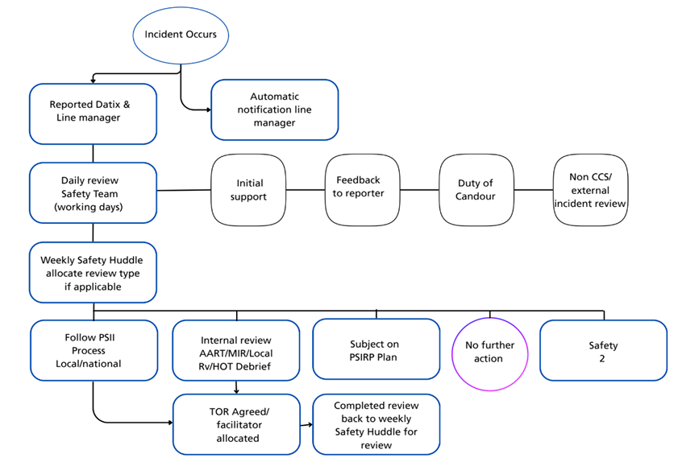

For services formerly under NCHC:
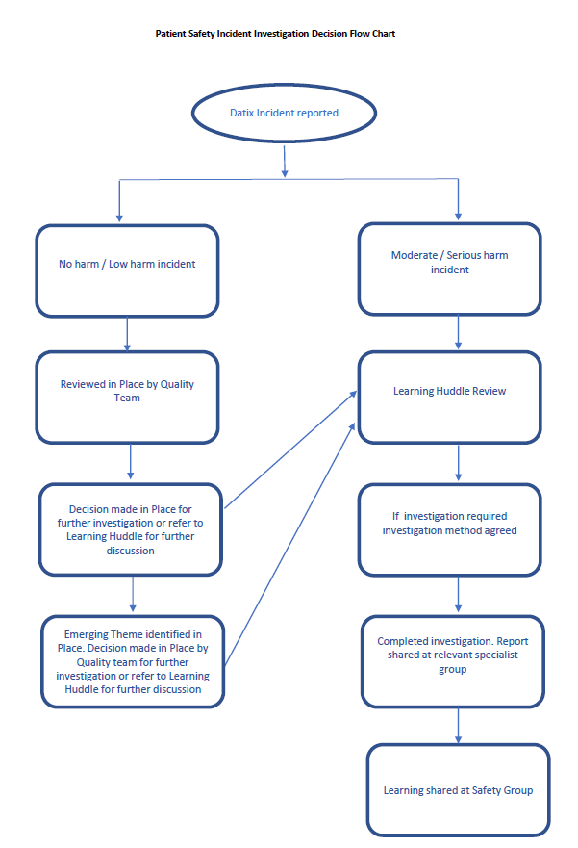

Governance structure Trust wide:

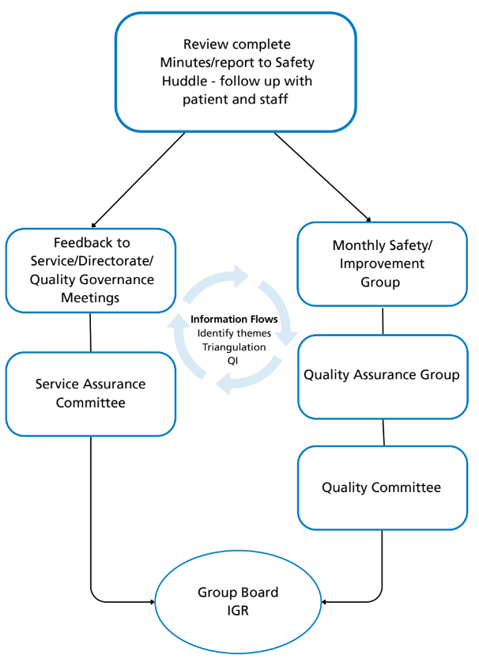

- Monitoring and Audit for Compliance
  - There is a robust system of reporting, oversight and governance in place supporting
the adoption of a proactive approach to the identification and management of patient safety incidents and any emergent theme.

The Quality Committee is the committee with the overarching responsibility for risk management and receives reports on clinical / non-clinical incidents and their management as per its workplan and terms of reference.

Safety improvement actions and associated measure(s) are appropriately reviewed to ensure they continue to be relevant and the issues of most concern with documentation, recording and reviews of progress against actions as part of the process.

- Equality Impact Assessment (EIA) and Quality Impact Assessments (QIA)

The author has carried out an Equality Impact Assessment (EIA) and a Quality

Impact Assessment (QIA).

EIA: QIA

APPENDICES

Appendix 1:

Patient Safety Specialist job requirements

Appendix 3: Guidance for the process of involvement, engagement and support

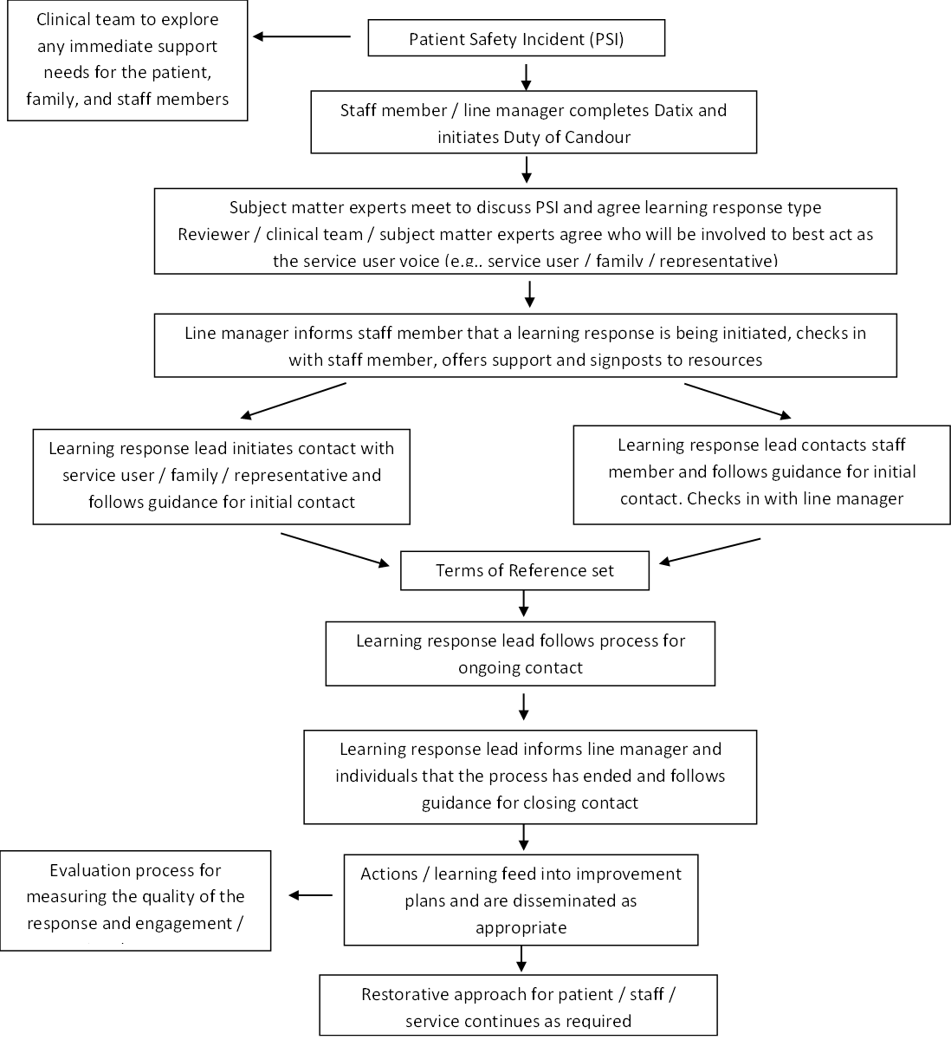

Guiding principles for engagement and involvement
• Apologies are meaningful • Approach is individualised, collaborative and open • Timing is sensitive • Everyone is treated with respect and compassion • Expectations are addressed • Guidance and clarity are provided • People are ‘heard’ • Subjectivity is accepted • Strive for equity

Appendix 4: Guidance for reviewers talking to Service Users

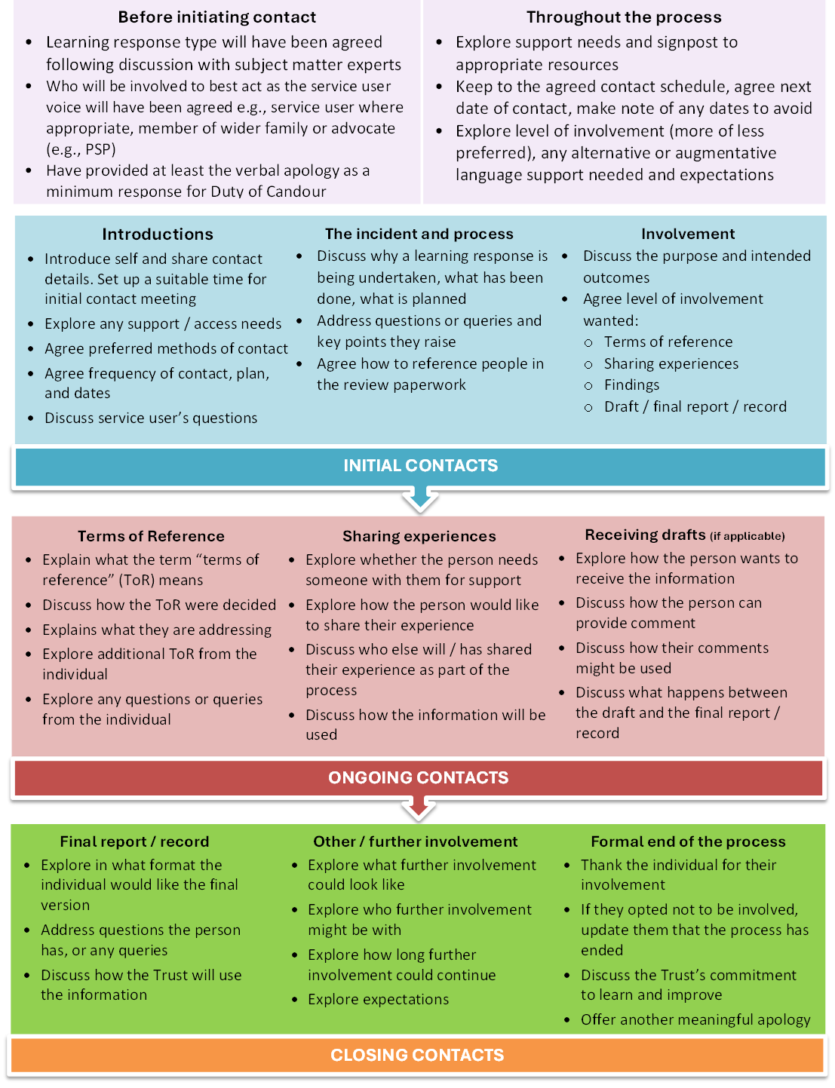

Appendix 5: Guidance for reviewers talking to Staff

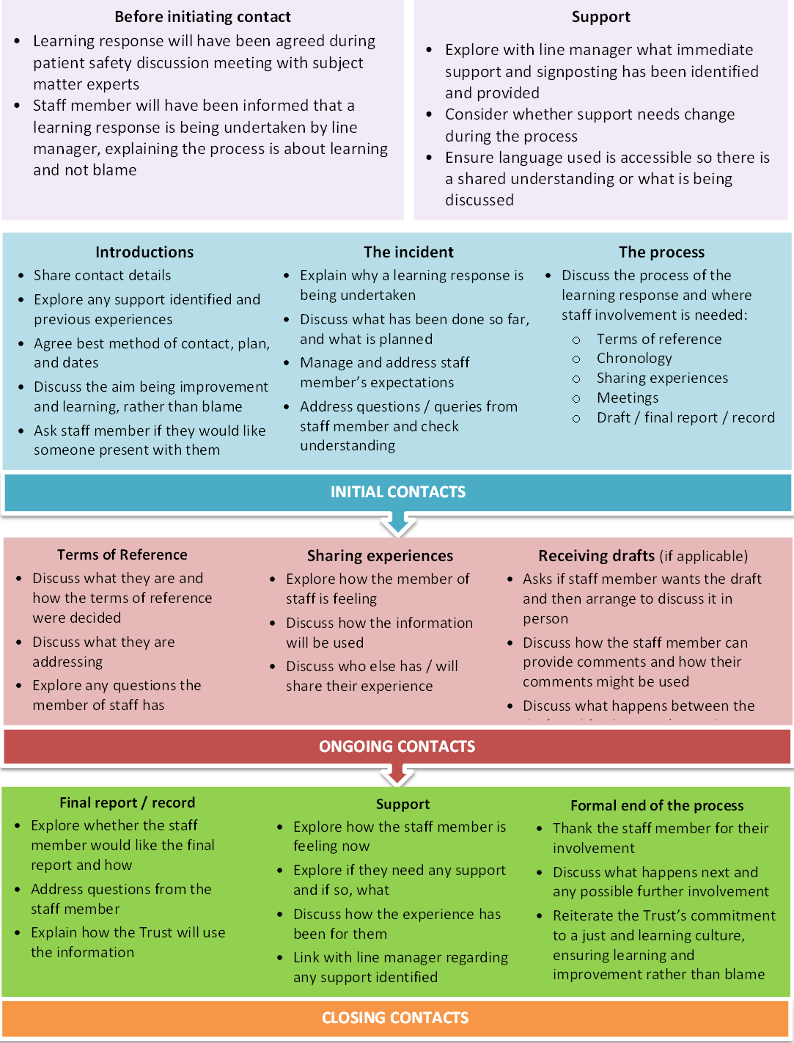

Statements

Consultation and development process | With the Quality and Safety teams and key stakeholders
Dissemination | Via Quality Committee and upload to the intranet
Financial Implications | Financial Implications: In line with the Economic Crime and Corporate Transparency Act 2023, the Trust has a framework in place to prevent and detect fraud, bribery, and corruption. This includes clear governance structures, financial controls, due diligence procedures, staff training, and accessible reporting mechanisms. The Local Counter Fraud Specialist (LCFS) plays a key role in supporting compliance through awareness, and the investigation of suspected wrongdoing. The Trust is committed to fostering a culture of integrity and transparency, ensuring all staff understand their responsibilities and know how to raise concerns. The LCFS contact details are available on the Trust’s Intranet.
Diversity & Inclusion Statement | Cambridgeshire Community Services NHS Trust will ensure that this policy is applied in a fair and reasonable manner that does not discriminate on such grounds as age, disability, gender reassignment, marriage and civil partnership, pregnancy and maternity, race, religion and belief, sex & sexual orientation.
Sustainability | Sustainable Development – Environmental  P Do you really need to print this document?  Please consider the environment before you print this document and where possible copies should be printed double-sided. Please also consider setting the page range in the print properties, when relevant to do so, to avoid printing the document in its entirety.

This is a controlled document. Whilst it may be printed, the electronic version on the Trust’s Intranet is the controlled copy. Any printed copies are not controlled. As a controlled document, this document should not be saved onto local or network drives, but should always be accessed from the Trust Intranet page.

